**Information Gathering Report**

**on**

**Passport Verification System using Block-Chain**

**Prepared by**

**Group No.: 04**

Group Members:

|  |  |  |
| --- | --- | --- |
| 1. Dipak Sarker Dipu | 201714021 | [dipu.mist@gmail.com](mailto:dipu.mist@gmail.com) |
| 2. Md. Ishak | 201714031 | [ishak.mist@gmail.com](mailto:ishak.mist@gmail.com) |
| 3. Rafin Lameya | 201714047 | [rafin.mist@gmail.com](mailto:rafin.mist@gmail.com) |
| 4. Tahasin Mahmud | 201714061 | [tahasin.mist@gmail.com](mailto:tahasin.mist@gmail.com) |
| 5. Tahmid Hasan Sakib | 201714062 | [thsakib.mist@gmail.com](mailto:thsakib.mist@gmail.com) |
| 6. Ismile Hossain | 201514027 | [ismile.mist@gmail.com](mailto:ismile.mist@gmail.com) |

|  |  |
| --- | --- |
| Submitted To: | **Lt. Col. Nazrul Islam, Lec Tarannum Zaki, Lec Shahrima Jannat Oishwee** |
| Course Title: | **System Analysis Design and Development** |
| Course Code: | CSE-402 |
| Date of Submission: | 03/04/2020 |

TABLE OF CONTENTS

Table of contents …………………………………………………………………….…. i

Abstract……………………………………………………………………….…………. 1

Introduction……………………………………………………………………………... 2

Information Gathering and Analysis………………………………………………… 3-9

Presenting The Existing System……………………………………………….… 10-11

Information Gathering Matrix…………………………………………………………. 12

Outcome Summaries …………………………………………………………………. 13

References……………………………………………………………………………… 15

**Abstract:**

A passport is a document, issued by a national Government. This certifies, for the purpose of international travel, the identity and nationality of its holder. The Elements of identity are name, date-of-birth, sex and place of birth most often, most often nationality and citizenship are congruent. A passport does not of itself entitle the passport holder entry into another country, nor to consular protection while abroad or any other privileges it does. However normally entitle the passport holder to return to his country that issued the passport. Rights to consular protection arise from international agreements, and the right to return arises from the laws of the issuing country. An individual can register for a passport irrespective of his/her age. The registration of a passport is a major step for issuing a passport. It is a system or process in which an individual has to provide exact details of his /her personal information and residential information. Proper registration of a passport is very vital as all the details filled by the individual are depicted on the passport that is issued.

**Introduction:**

Passport or Visas are one among the identification documents that are viewed as sound and astonishing. They are considered as the most credible and high-quality travel and recognizable proof report across the globe. Any individual who has experienced the way towards applying for the international ID – passports or visas, realizes how uncompromising the whole scenario is. The Procedures run down

to a strict application process that requires a scope of supporting documentation, for example, a birth testament and confirmation of citizenship. It is no big surprise that lawbreakers charge a high cost for passport frauds. Today counterfeit visas have been connected to secret shady activities like smuggling, drugs, frauds, and scope of other criminal exercises. It is a matter of great concern. As it is very difficult to identify the fake from real. The increasing rate of phony or the fake passports, keep on troubling the government in one or other way.

It is witnessed that the government and the verification bodies of various nations have tremendously failed in identifying the real passports and verifying them in a short time. Under the normal set up, it remains quite challenging to distinguish the counterfeit passports from the real ones.

However, with the introduction of block chain technology, the fear of immutable records is ruled out. Document verification under block chain has proved itself with a lot of significations like immutable records, supreme security, cheaper transactions, action traceability, proof of ownership, proof of integrity and more. In nutshell, the document verification process that uses block chain innovation and smart contracts will simply enable the government and other designated authorities to confirm that the identification you are taking is valid and credible

**INFORMATION GATHERING AND ANALYSIS**

**Overview and Objectives**

For passport verification, the present address of the passenger must be under the same Metropolitan/District police jurisdiction as the present, permanent or emergency contact address mentioned in the passenger's passport. In case of a foreign passport holder, present address means the address where she/he lived during his/her stay in Bangladesh. In case the passenger's passport does not contain any address, the passenger's present address must be supported by National ID Card, Birth ID Card or local Ward councillor certificate has to be attested by Class one gazetted officer. A foreign passport holder, residing abroad, seeking police clearance from Bangladesh must get his/her passport attested by a Justice of Peace in his/her country of residence to upload with the application. Bangladeshi nationals applying from abroad must get his/her passport attested by Bangladesh High Commission of his/her present country of residence and upload with the application. A foreign passport holder, residing abroad, seeking police clearance from Bangladesh must get his/her passport attested by a justice

of Peace in his/her country of residence and upload with the application. Police Clearance is issued through this system to only Bangladeshi nationals going or residing abroad and foreign nationals returned abroad after their stay in Bangladesh. Police Clearance required for employment or other purposes within Bangladesh are requested to contact concerned District or City Special Branch.

The reason behind framing of every rules, regulations, laws, is provocative unlawful, unruly behaviour of the public itself and this doesn't mean that any democratic government intends to force its superlative wish of authority on its public. The rule for police verification before issuing any passport is working on the same criteria. It only intends to thwart the efforts of any unruly, unlawful person to go out of the country on the basis of the passport issued to him/her and definitely this intention is achieved in most of the cases by imposing the necessity of the police verification. There may be fewer examples of wrongly issued passport which proves that the concerned passport/police officials were either misled by providing unauthentic information/documents or by bribing the officers of both these departments.

**Information Required for System Analysis**

. **Method of information gathering.**

   a. Questionnaires (Method-1).

b. Literature review (Method-2)

c. Onsite observation (Method-3).

**Sources of Information.**

a. Passenger(Source-1).

b. Immigration officer (Source-2).

c. Administrators authority (Source-3).

d. Data Entry Supervisor(Source-4)

**Information needed.**

a. Availability of the national database for people who are living in Bangladesh and who are staying outside of Bangladesh? (Information-1)

b. How do the passports are verified of the passengers? (Information-2)

c. How confidentiality, integrity and accessibility of passenger information are maintained? (Information-3)

d. How is the backup system for database maintained? (Information-4)

e. How to identify if a passport is valid or invalid ? (Information-5)

f. What are the challenges of security in passport verification ?

(Information-6)

**Information Gathering.**

**Information Gathered through Questionnaires (Method-1).**

|  |  |  |
| --- | --- | --- |
| **Information needed** | **Information got** | **Outcome** |
| 1. Availability of the national database for people who are living in Bangladesh and who are staying outside of Bangladesh? (Information-1) | Yes, record is available who are living in Bangladesh and who are staying outside the Bangladesh | Sometimes broker make fraud passport to earn money .(Outcome-1) |
| 2. How do the passports are verified of the passengers? (Information-2) | Passport are verified through the passport scanner | Passenger have to wait for a long time to verify his passport(Outcome-2) |
| (3) How confidentiality, integrity and accessibility of passenger information are maintained? (Information-3) | Passengers’ information is secured but sometimes it can hacked | Confidentiality and integrity of records are not always maintained. (Outcome-3) |
| (4) How to identify if a passport is valid or invalid ? (Information-5) | If the given information is not matched with the database information and retina scan is not matched with the person then the passport became fraud | Records accessing previous data is difficult (Outcome-4) |
| (5) What are the challenges of security in passport verification ?  (Information-6) | To identify the passport is real or not real | Sometimes hacker can hack the information of user and can make fake passport(Outcome-3) |

**What is the rating of current system from stake holder point of view?**

|  |  |  |  |  |  |
| --- | --- | --- | --- | --- | --- |
| **Stakeholders** | **Very poor** | **Poor** | **Good** | **Fair** | **Excellent** |
| Passenger | 1 | ✓2 | 3 | 4 | 5 |
| Immigration officer | 1 | 2 | ✓3 | 4 | 5 |
| Administrators authority | 1 | 2 | ✓3 | 4 | 5 |
| Data Entry Supervisor | 1 | ✓2 | 3 | 4 | 5 |

**Outcome**: The current system operability is not efficient

**Review of Existing Literature (Method 2)**

* A recent survey conducted by Transparency International Bangladesh (TIB) found that three out of four new passport seekers had to pay speed money to get clearances.
* These include police verification and attestation of documents.
* The survey conducted from September 2016 to May, 2017 concludes that more than half of passport seekers have fallen victim to various types of irregularities, harassment and corruption.
* Although the latest survey, the percentage of victims have fallen from 77.7 percent to 76.2 percent from one conducted in 2015, the fact is that things have not really improved all that much.
* Although there have been demands to end police verification altogether, we need some sort of verification nonetheless. But it must be ensured also that ordinary citizens can avail this basic document without being forced to pay bribe to law enforcers or brokers for that matter

**Documents Reviewed During Feasibility Research:**

|  |  |
| --- | --- |
| **Document** | **Summary** |
| The Daily Star Report about passport verification. | System structure and system elaborately discussed. |
| Wikipedia | Detailed discussion about the passport verification process. |
| Police clearance website | Detailed explanation of policy of police to verify the passport. |

**Source of gathering information**

**How does it work:**

Our Customer just needs to place their passport onto the passport scanner, which then inspects the photo of their face alongside performing numerous other checks, before returning a result that you can trust with confidence.

Our passport verification system combines state-of-the-art image processing, algorithms and an encyclopedic knowledge of passports to verify whether a passport is authentic or not.

Using 3 different types of light to scan white, infrared and ultraviolet, the passport verification system extracts data via optimal character recognition which is then harmonized with our vast datasets. The authority can review all the details of the scan, including the tests that were run, those that passed and those that failed. Facial recognition is used to incorporate in the process for an extra layer of authentication. A passport verification system can provide instant validation of facial features between a printed document face and a live facial image captured on a smart phone, tablet or webcam.

We use Optimal Character Recognition and 3 different types of light to scan ID and extract data:

* **White**: this is what our eyes see. Using white light, we can extract data, the portrait picture, and check for tampering
* **Infrared**: this will read the sub-layer of the document, not visible to the naked eye. This scan will identify any tampering or forgery
* **Ultraviolet**: this scan will extract the ultraviolet pattern, not visible to the naked eye

**Where does it work:**

Hardware passport verification:

A passport verification system is ideal for use in airport and within a number of industries, particularly banking or telecoms, where providing someone’s identity is critical to protect a organization. In hardware a passport verification scanner is used and performs as a standalone solution.

Online passport verification:

In an online business customer can upload their passport for quick and easy online verification. Smart phone is used to as passport verification system.

**Information Gathered through On-Site Observation (Method-3).**

(Sources-): Hazrat Shahjalal International Airport

|  |  |  |
| --- | --- | --- |
| **Information needed** | **Information got** | **Outcome** |
| 1. Availability of the national database for people who are living in Bangladesh and who are staying outside of Bangladesh? (Information-1) | Yes, record is available in admin database | But sometimes the server may go down .(Outcome-1) |
| 2. How do the passports are verified of the passengers? (Information-2) | Passport are verified through the database identification and retina match | People have to wait for a long time and sometimes machine does not work (Outcome-2) |
| (3) How confidentiality, integrity and accessibility of passenger information are maintained? (Information-3) | Passengers’ information is secured but fake passport can be made | To main the confidentiality of data is tough (Outcome-3) |
| (4) How to identify if a passport is valid or invalid ? (Information-4) | If the given information is not matched with the database information and retina scan is not matched with the person then the passport became fraud | Sometimes people have to suffer for a not matching finger print etc (Outcome-4) |
| (5) What are the challenges of security in passport verification ?  (Information-5) | To identify if there is a fake passport or not | People sometimes suffer for wrong spelling of name and face recognition (Outcome-5) |

**PRESENTING THE EXISTING SYSTEM**

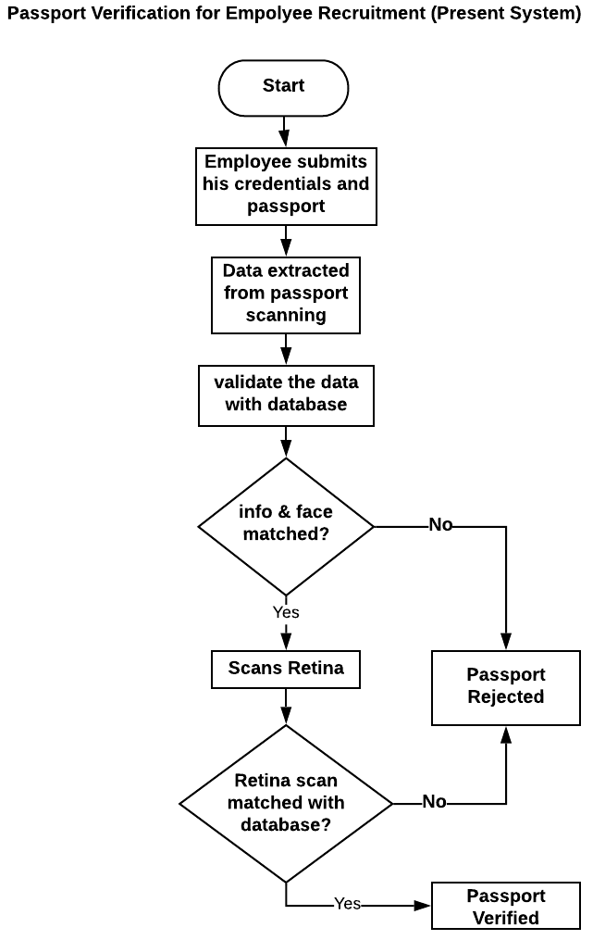

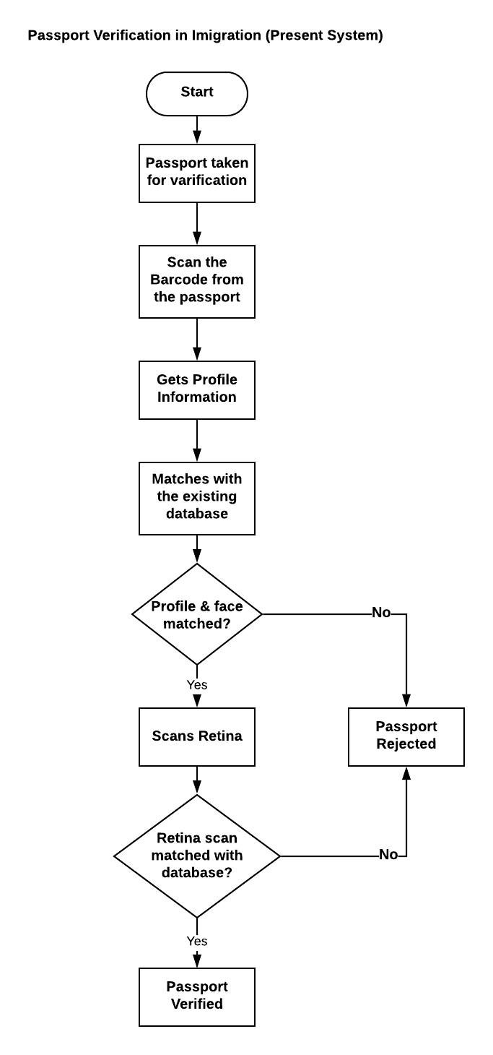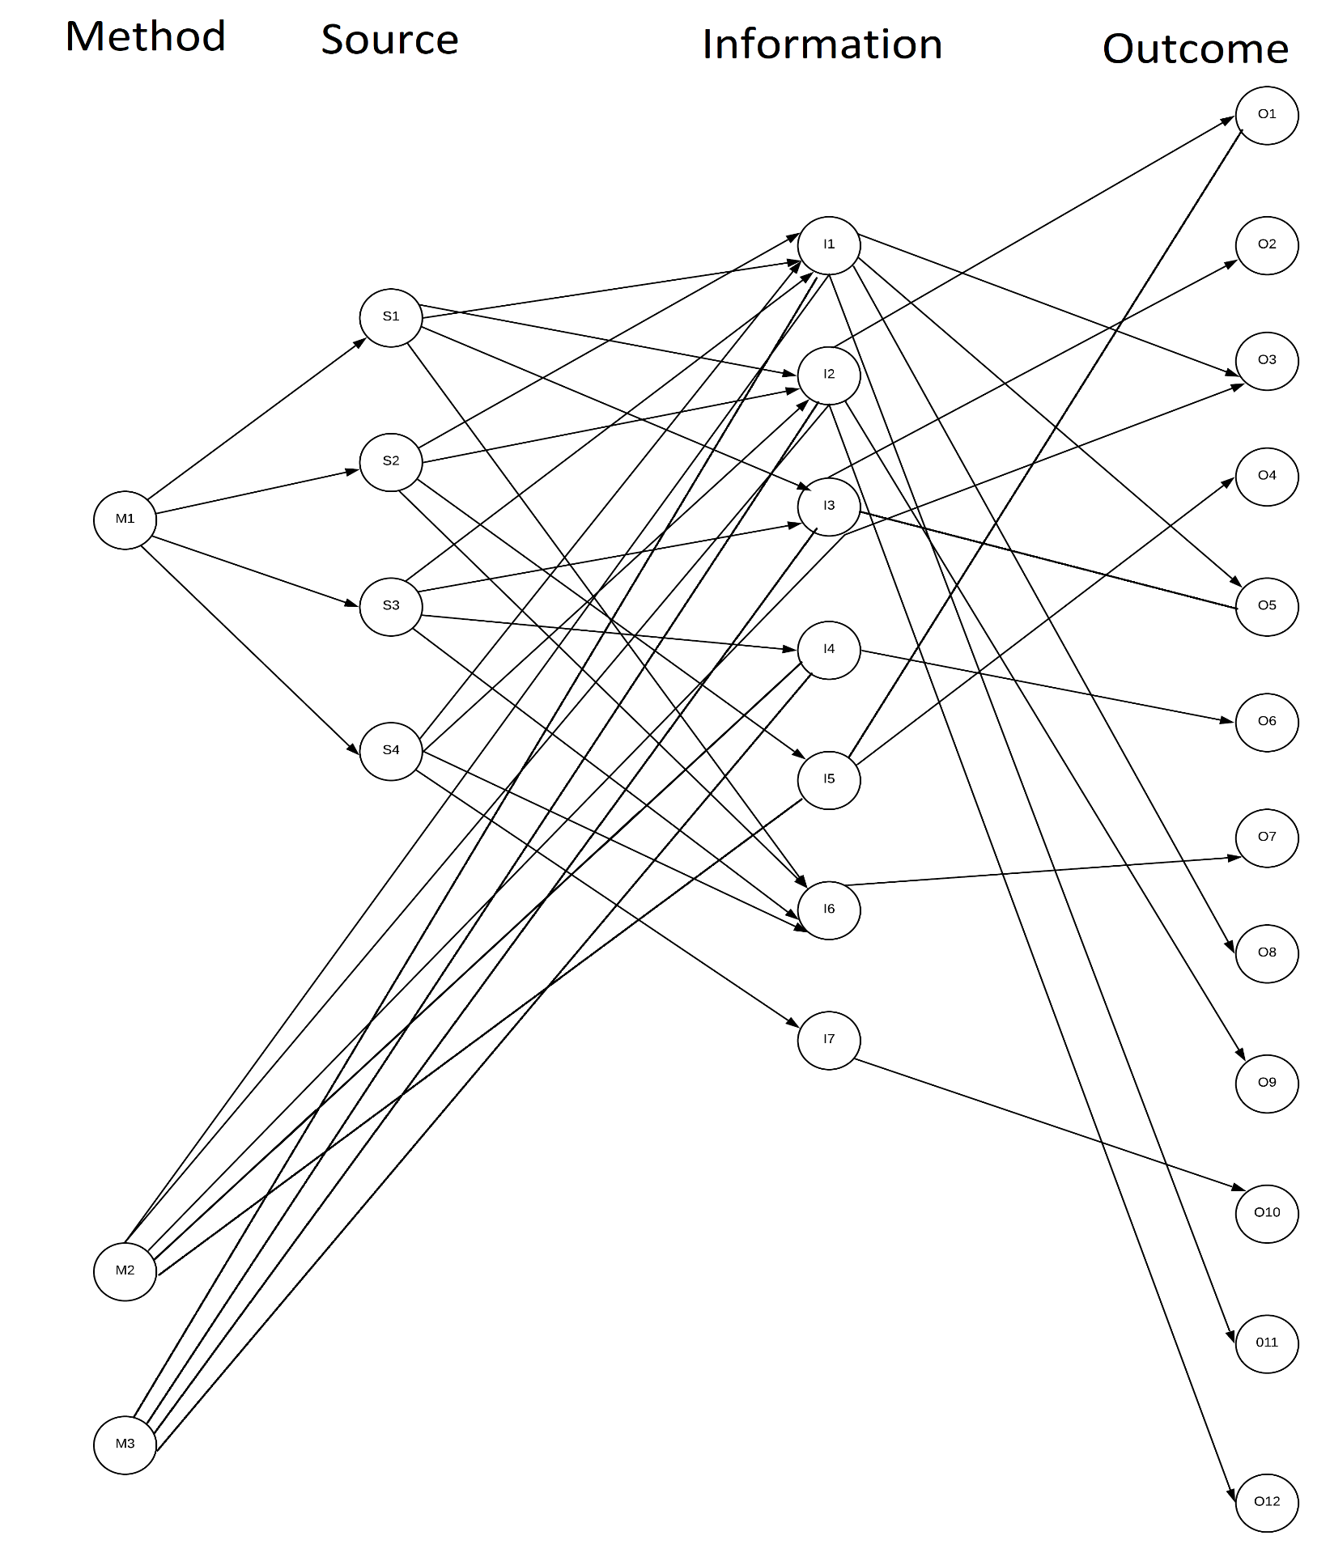**Information Gathering Matrix:**

**5. Outcome summaries:**

O1. Sometimes user record is not found in database

O2. Confidentiality and integrity of records are not always maintained.

O3. Accessing previous data is difficult.

O4. Keeping records is much more convenient for future references.

O5. As fake report is made so it is quite difficult to verify real passport

O6. People have to wait for a long time for verification

O7. The current system operability is poor.

O8. Central database can be hacked any time

O9. Security system needs to be more efficient

10. Reliable system with proper integrity must be assured.

**Conclusion:**

Passport verification in Block chain Passports or Visas facilitate safe movements across nations. Be that as it may, in 2016, the loss of almost 20,000 international IDs were accounted for. Such episodes lead to a rising alarm in wrongdoings like data fraud. Also, manual identification checks are wasteful, and it can cause delays in airports and borders.

The system which is selected through the analysis stages is comparatively cheap and efficient. Here the security system depends on hashing technique and authorities actions which reduces the cost significantly compared to the other existing system.

This challenge will be more stretched with the expanding number of voyagers. To battle the challenge in visa verification, the government needs to locate a compelling arrangement that Block chain innovation can give. Block chain for visa verification can be a smart solution for many reasons. This blog runs down the benefits of block chain in the passport and visa verification. Block chain can be called the future of visa verification or passport verification. The implementation of block chain technology in visa verification could be the eventual fate of the visa, as it offers an immutable digital ledger for verifying the individual identity.

***References:***

*1.*[*https://www.blockchainexpert.uk/blog/how-helps-in-passport-verification*](https://www.blockchainexpert.uk/blog/how-helps-in-passport-verification)

*2.*[*https://support.com/hc/en-us/articles/360018080172-Identity-Verification-Overview*](https://support.com/hc/en-us/articles/360018080172-Identity-Verification-Overview)

*3.*[*https://ieeexplore.ieee.org/document/8691939/*](https://ieeexplore.ieee.org/document/8691939/?fbclid=IwAR2d6m5_5EBi_Y0-JcLQyo5d6k6LynjlCcPlpq_BoPoS44_Q99lRldf-hyE)

*4.*[*https://succeed.com.mt/travel-with-passport/*](https://succeed.com.mt/travel-with-blockchain-passport/?fbclid=IwAR2tYgIE24kOtv7mG9eaaiLeiKPMqmnZTjagIatdEdqAlXgrEV0dXuh_F2c)

*5.*[*https://iqsasoft.com/case-studies/case-studies-view*](https://iqsasoft.com/case-studies/case-studies-view?fbclid=IwAR0pW2qg9shFxeu4BTOzbqke-pFx-CbltkmjLWhTidkBb0dF8q_VVlnx_8w)

*6.*[*https://www.veridocglobal.com/ID*](https://www.veridocglobal.com/ID?fbclid=IwAR274YPCFiqzeIl-DZsN7BG6cDpVR-sSgZai7Q-fOjU89RtZ_-pGF6ZiUl0)

*7.*[*https://www.org/passport-verification/*](https://www.org/passport-verification/)

*8.*[*https://www.europeanbusinessreview.com/-can-bring-a-new-way-of-approaching-identity-proof/*](https://www.europeanbusinessreview.com/-can-bring-a-new-way-of-approaching-identity-proof/)

*9.*[*https://www.slideshare.net/CelineGeorge1/how-helps-in-passport-verification*](https://www.slideshare.net/CelineGeorge1/how-helps-in-passport-verification)